AT Training Workbook

Institutional Led Review Training
Workbook

Contents

Introduction
Agenda
Session 1: What is an Institutional Led Review?
- Introduction
  - What is Quality Enhancement?
  - The Quality Enhancement Framework
  - UK Quality Code for Higher Education
  - Subject Benchmarks
  - What is an Institutional Led Review?
    - What is your role in an ILR?
  - ILR at your university
Session 2: Interpreting Review documents
2. Introduction
2.1. Dealing with documentation
2.1.1. Understand the structure
2.1.2. Prioritise your reading
2.1.3. Reading effectively
2.2. Tips for effective reading
2.3. Characteristics of an ILR: what to look out for
Session 3: Skills required to be an effective Reviewer

The importance of effective communication

Listening

Questioning

Feedback

Facilitation

Tips for effective communication
Session 4: Practice Review Panel Pre-Meeting
Session 5: Practice meeting with key staff
Resources
Quality Enhancement partners

Introduction

This course has been designed to equip you with the skills and knowledge to be an effective member of an Institutional Led Review Panel at the University of XXX.

By the end of the course you will:

- Be able to explain the purpose of an Institutional Led Review.
- Be able to define your role within the Review Panel.
- Have developed the necessary skills to complete a review.
- Put all you have learned into practice.

About your workbook

Over the day we will cover a large amount of detailed information. In order for you to get the most out of this course, this workbook has been provided to help you to structure your note-taking so that you can refer back to it throughout the forthcoming year. You will be asked to revisit the workbook at various points throughout the course, but also feel free to use it to jot down your own notes and ideas.

The workbook also aims to enhance your learning experience by acting as a tool for reviewing your learning. It will enhance your learning, thinking and remembering skills and will increase your knowledge and your confidence.

Contacts

Add details of key institutional contacts.
Agenda

30 mins Welcome and introductions

45 mins What is an Institutional Led Review?
In this first session we will provide you with a background to Institutional Led Review, including where it sits within the Quality Enhancement Framework as well as the details of how it is run here at University of XXX.

60 mins Interpreting Review documents
You will be examining what type of documentation a review uses and how best to approach them in this session. You will then put those skills into practice.

60 mins Skills required to be an effective Reviewer
This session will cover how to effectively communicate, question, listen and give feedback during the Review.

45 mins Practice Review Panel meeting
You will get the chance to put the skills learned in the previous session into practice during this session.

45 mins Practice meeting with School staff
This session will allow you to put all you have learned during the day into practice.

15 mins Conclusions
We will wrap up the day bringing together all the information from throughout the day and answer any questions you may have.

Session 1: What is an Institutional Led Review?

Session Aim

This first session will provide you with a background to an Institutional Led Review, including where it sits within the Quality Enhancement Framework as well as the details of how it is run here at the University of XXX.

Session Objectives

By the end of this session you will:
- Be able to explain the background of Internal Subject Review.
- Be able to explain the process of undertaking a Review.
- Be able to explain the role of students in a Review.

Your notes:

- Introduction

This section explains the wider quality context of which the Institutional Led Review (ILR) is one aspect. While you are likely to only be involved in the ILR in your university it is useful to see that by doing so you are contributing to a national process of ensuring the quality of Scottish university education. This section therefore looks at the Scottish approach to quality enhancement then considers some UK tools that are applicable in Scotland. Institutional Led Review is then explored in more detail.

  - What is Quality Enhancement?

Quality enhancement is defined as ‘Taking deliberate steps to bring about improvement in the effectiveness of the learning experiences of students’ (ELIR Handbook, 2012).

The Joint Quality Review Group, which reported to the Scottish Funding Council in 2007, established three key principles which inform and underpin quality assurance and enhancement. These are:

- Quality culture.
- High quality learning and teaching.
- Student engagement.

This is translated into practice by the Quality Enhancement Framework (QEF).

  - The Quality Enhancement Framework

All of Scotland’s universities work within the Quality Enhancement Framework which is overseen by the Quality Assurance Agency in Scotland (QAA). QAA works in partnership with other agencies and the university to ensure students are engaged in quality assurance and enhancement processes.

There are five main elements to the QEF:

- Institutional led reviews are run by the universities themselves and assure and enhance the quality of the student learning experience. The reviews are for all credit-bearing provisions including Continuing Professional Development, postgraduate awards, collaborative and overseas provision, supervision of research students, as well as online and distance learning. This is discussed in more detail below.

- Enhancement-led Institutional Reviews which involve all Scottish universities over a four-year cycle and are managed and run by QAA. It reports on the quality of learning within universities based on:

- management of the student learning experience;
- monitoring and review of quality and academic standards (quality assurance); and
- a strategic approach to quality enhancement.

- Ensuring that public information about quality is adequate to meet the needs of different stakeholders, including students and employers, and is uniform across the sector.

- Student involvement in quality processes. QAA supports the involvement of students in quality management through its partnership work with sparqs and NUS Scotland. Consideration of student engagement within the other elements of the QEF is integral to QAA’s approach to review of universities.

- Enhancement Themes aim to enhance the student learning experience through identifying specific areas for development. They encourage academic and support staff, and students collectively to share current good practice and to generate ideas and models for innovation in learning and teaching.

For more information on the QEF visit the QAA website at http://www.qaa.ac.uk/Scotland/AboutUs/Pages/Quality-enhancement-framework-in-Scotland.aspx

Your notes:

  - UK Quality Code for Higher Education

The Quality Assurance Agency has produced a Quality Code for all UK universities that sets out defined Expectations that universities are required to meet. Universities are expected to use it when designing and delivering programmes of study. It aims to unify academic standards for programme design, delivery and the quality of learning opportunities but it is framed in terms of principles to be met rather than explicit actions. QAA reviewers use it as the main reference point for their review work i.e. during ELIR.

It is in three parts:

Part A: Setting and maintaining threshold academic standards.
Part B: Assuring and enhancing academic quality.
Part C: Information about higher education provision.

Each of these is subdivided into Chapters covering specific themes including Chapter B5: Student Engagement.

The Quality Code can be found at http://www.qaa.ac.uk/AssuringStandardsAndQuality/quality-code/Pages/default.aspx

  - Subject Benchmarks

Subject benchmark statements were developed by QAA, the relevant professional body and the Scottish Government. The statements bring together the academic and practice-based elements of programmes and the relevant professional requirements or National Occupation Standards. They set out expectations about standards of degrees in a range of subject areas. They describe what gives a discipline its coherence and identity, and define what can be expected of a graduate in terms of the abilities and skills needed to develop understanding or competence in the subject.

Subject benchmarks can be found at http://www.qaa.ac.uk/AssuringStandardsAndQuality/subject-guidance/Pages/Subject-benchmark-statements.aspx

  - What is an Institutional Led Review?

An overarching principle in quality management in Scottish universities is that quality is owned by the institution, however, institutional led reviews are scrutinised through the ELIR process.

There is generic guidance from the Scottish Funding Council that outlines how an ILR should be carried out, but how the university conducts reviews is entirely up to it as long as it follows the guidance and the review is rigorous and robust.

- All provision should be reviewed on a cycle of not more than six years.

This is usually a rolling programme of reviews over six years rather than over three with three years off. All credit bearing provision should be considered, however, the focus is likely to be on undergraduate programmes. The role of support services should also be considered.

- Reviews should take account of benchmarks and the Quality Code.

The Quality Code sets out minimum Expectations on quality standards for all universities and should be followed, as should the benchmarks which are well established and recognised tools for quality. The SFC also suggest that wider resources such as Enhancement Themes, Scottish Higher Education Enhancement Committee (SHEEC), the work of the Higher Education Academy, advice from sparqs and reference points such as the UK Professional Standards Framework (UKPSF) are also considered.

- The Scottish Credit and Qualifications Framework should be used.

The Scottish Credit and Qualifications Framework (SCQF) is a method of establishing the level of a qualification. It uses the level of a qualification or learning programme and the number of Credit Points awarded to compare the various Scottish qualifications. The level of a qualification indicates the level of difficulty and the number of credit points indicates the length of time it takes to complete.

- Review teams should include an objective opinion

All review teams should include at least one external member. This should include an external with relevant experience from another university but can also include someone from industry, a stakeholder organisation or from a university outside the UK.

- All review processes should fully engage students.

- Annual monitoring arrangements and follow-up action for programmes should be considered.

All universities operate annual monitoring across provision such a student survey data, performance data on recruitment, progression and achievement. This information should be considered for benchmarking purposes.

- Assurance and enhancement.

All review processes should be robust and comprehensive in assessing quality but the SFC places a lot of weight on evidence for enhancement as well as assurance.

    - What is your role in an ILR?

You are the student panel member on the ILR team which means you are there to bring the student perspective to the entire review. You will be expected to be a full panel member throughout the entire process and therefore question and contribute to the discussion in all of the sessions not just the student sessions. It is not enough for you to identify and respond to the obviously student issues: as a full panel member you must contribute your unique perspective to all elements of the review. You are also likely to be responsible for facilitating several sessions.

  - ILR at your university

Session 2: Interpreting Review documents

Session Aim

You will be examining what type of documentation a review uses and how best to approach them in this session. You will then put those skills into practice.

Session Objectives

By the end of this session you will:
- Be able to list the various types of documentation you will encounter when on a review.
- Have considered several methods for tackling the documentation.
- Have practiced analysing review documents.

Your notes:

- Introduction

The school being reviewed will submit a considerable amount of documentation prior to the review event, ranging from the Self-evaluation Report drafted by the department/school themselves, to documents external to the institution. You will also have access to other documentation during the review. It is vital that you familiarise yourself with this documentation so you can understand what is happening and be more proactive as a reviewer.

There will also usually be documentation available on the day which the panel can review to help answer any questions that they may have. Therefore it’s important to have the required skills to be able to analyse and interpret such documents effectively. It’s unlikely that you will have time to read all of it to the extent that you fully understand and remember it all so it is important to plan your time and prioritise your reading.
What types of documentation might you receive?

2.1. Dealing with documentation

As a student you will already be familiar with how much information you have to process and absorb for your degree. The skills you use to manage this can be transferred and used to manage the Review documentation.

    - Understand the structure

You will receive an organised bundle of papers and you’ll need to familiarise yourself with them. During the Review meeting you might need to quickly refer to a paper so you will need to remember the structure of the documentation. Go through the contents or key headings to capture the overall structure of the document and consider:

  - What are the obvious sections directly linked to students and the student perspective?
  - What are the other sections that are less directly linked to students but still have an impact on the student learning experience?

Don’t forget: you are a full member of the review panel, so do not ignore sections that might not seem student-focused at first glance.

    - Prioritise your reading

There will be a huge amount of reading you will need to do and it is unlikely you will be able to read everything you are sent to the extent you might want to. You will need to prioritise your reading to make sure you have read the documents that are important to the student learning experience. Doing this will help you with your time management.

A useful tool for prioritising is the “Urgency/Importance Grid”. Managing your time effectively, and achieving the things that you want to achieve, means spending your time on things that are important and not just urgent.

Important activities have an outcome that leads to the achievement of your goals, whether these are professional or personal.

Urgent activities demand immediate attention, and are often associated with the achievement of someone else's goals.

- The first step is to list all the papers that you feel you have to read.
- Next, on a scale of 1 to 5, assign importance to each of the papers. Remember, this is a measure of how important the reading is in helping you understand the student facing issues. Try not to worry about urgency at this stage.

- Once you've assigned an importance value to each activity, evaluate its urgency. As you do this, plot each item on the matrix according to the values that you've given it.

URGENCY
IMPORTANCE

- Urgent and Important
There are two distinct types of urgent and important papers. Ones that you identify as such and plan for, and one’s that become this because you’ve left it to the last minute. You can avoid last-minute reading by planning ahead and avoiding procrastination.

- Urgent and Not Important
Urgent but not important papers will that stop you reading the urgent and important papers, and prevent you from completing your work. Ask yourself whether these documents can be read later.

- Not Urgent, but Important
These are the papers that will give you a deeper understanding of the work in the department/school. Make sure that you have planned effectively to allow time to read them properly, so that they do not become urgent.

- Not Urgent and Not Important
These papers are less relevant to you when considering the student learning experience and should be left to the end if you have time

    - Reading effectively

Once you’ve prioritised your reading you then actually have to read it! A good process to follow is:

- scan the title of the section and parts of the content to see if it is relevant.
- skim the text to gain an overview of its content and confirm how centrally relevant it is.
- intensively read the whole text to understand and evaluate its content in depth.

Now is the time to start making connections between all the information and identifying questions you might have for clarification.
  - Tips for effective reading

- Go through the sections in the order that you have prioritised them.
- Write down your current knowledge on the various sections of the documents.
- Summarise briefly each paragraph in the margin.
- Write questions you already have at this stage. Make a note of the page it relates to.
- Note questions as you go and note the page/section your question relate to.
- Write down additional questions you have after your reading.
- Write down things that you need clarification on.
- Use colour coding (highlighters and coloured tabs) to order your questions.

Characteristics of an ILR: what to look out for

Student Learning Experience
ILRs assure and enhance the quality of the student learning experience. As a reviewer, you therefore need to make linkages between the different elements of the student learning experience and the content of what is reviewed.
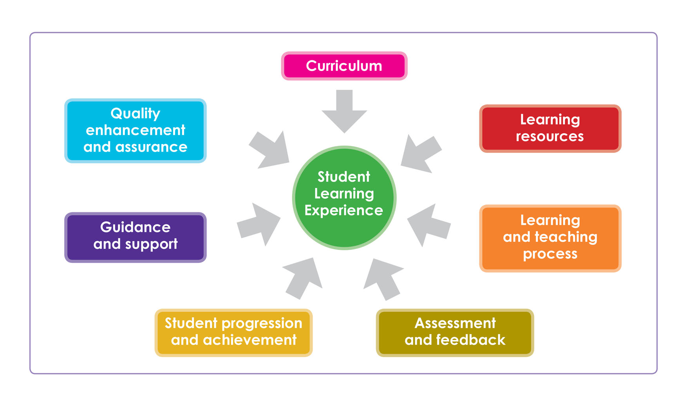
Curriculum
ILRs are for all credit-bearing provisions including Continuing Professional Development, postgraduate awards, collaborative and overseas provision, supervision of research students, as well as online and distance learning. No provision of a given subject should be omitted from the review.

Learning resources
You will be given information on the kinds of resources students need to complete their course. This may be particularly important if it includes lab or computing facilities as you will also have an opportunity to meet with the technical support staff who will be able to give their views on the adequacy of learning resources.

Learning and teaching process
Teaching staff will talk through how the classes are structured and the rationale for teaching strategy, such as contact hours versus self-directed learning, lab time compared with taught classes and work experience opportunities.

Assessment and feedback
This is in relation to course assessment and feedback on course work and exams. It is likely the Department will have a policy in place to provide feedback to students which you will see. Staff and students may also have a view on the value or efficacy of the current assessment process and marking criteria which you may want to explore.

Student progression and achievement
You will receive information on the routes students take when they leave the course. You will need to analyse this information in light of satisfaction surveys, student feedback and national trends for that subject area. The ILR will assess the suitability of the course for meeting graduate employment needs.

Guidance and support
These include guidance, learning resources, ICT, recruitment, student finance etc.
In the framework of an ILR the institution needs to provide evidence that support services contribute to the quality learning experience within the institution, as well as the way these services engage with students to improve and monitor the quality of those services.

Quality enhancement and assurance
University processes should take full account of student feedback, and include procedures to obtain student views of the provision being reviewed. All categories of students need to be taken in to account (i.e. part-time/full time etc). ILRs have to take full account of student feedback and no category of students should be omitted.

All universities conduct annual monitoring of their education provision.

Monitoring includes:
  - Student survey data.
  - Performance data on recruitment.
  - Progression and achievement.

ILRs should allow for reflection on the effectiveness of such monitoring and the follow-up on the outcomes further to the monitoring of the above elements.

Session 3: Skills required to be an effective Reviewer

Session Aim

This session will introduce you to the practical communication skills you will need to be an effective reviewer.

Session Objectives

By the end of this session you will:
- Be able to identify the main communication skills a reviewer will use;
- Be able to confidently explain the purpose and effect of good communication; and
- Have practised using these communication skills.

Your notes:

The importance of effective communication

Being aware of the importance of being an effective communicator as a reviewer will help you taking the most of the experience of being a reviewer.

You will be working with three main audiences:

your team (i.e. the review team);

the review organisers (i.e. quality office or similar);

the team being reviewed i.e. the people you will be engaging with during the review event including students.

You will be communicating with each of these groups for different purposes and in different ways – you will have to adapt your communication style depending on the audience and the context.

You need to think about:
What do you want to communicate?
How can you best get the message across?
What is the environment?
Who do you want to communicate to?
What is the timing?

Listening

Listening is more than the function of hearing. It is a process whereby you must focus on the message to understand it, analyse and evaluate the message before considering a response if necessary. Sometimes we listen better and more effectively than other times.

There are two types of listening: passive and active listening.

Passive or attentive listening is listening without reacting. It is allowing someone to speak, without interrupting and not doing anything else at the same time. Passive listening takes place when you focus on hearing and understanding the message with a genuine interest, but the listener does not follow-up with what they have been told i.e. fails to take action.

Active or reflective listening takes place when the listener is genuinely interested in what the speaker says, and when the listener verifies their understanding of the message with the speaker. Active listening is reacting or doing something that demonstrates you are listening and have understood. It is giving non-verbal cues to demonstrate you are paying attention for instance nodding, making eye contact and making facial expressions appropriate to what is being said. It is reflecting back the main points and summarising what has been said.

For the purposes of the review you will need to actively listen during interviews in order to hear fully what is being said, but to also critically evaluate the conversation and to be able to explore in more depth what you are being told.

There are different ways to practise active listening:

Mirroring
This is repeating back phrases or words the speaker uses. This shows the speaker that you have listened and it gives them a sense of recognition.

Paraphrasing
This is rephrasing or restating what you have heard in your own words to ensure that you have understood the content of the message. It give the speaker an opportunity to elaborate on or clarify what they are saying and might stimulate greater objectivity by the speaker.

Summarising
Summarising involves pulling together the main elements of the discussion and organising them so that they can be reviewed, confirmed or corrected.

Your notes:

Questioning

Questioning serves different purposes: it enables you to get a response to a query, but it can also help you to clarify an issue; or even prompt action in the person you ask the question of.

There are two types of questioning and they each will give you different outcomes.

Closed questions should invariably get a yes/no or facts as answers. For example, “Are you thirsty?” Closed questions are useful when you want very specific information; to establish agreement; or to check something before going any further.

Closed questions are not helpful when you want to invite people to talk about themselves and their experiences. They have the potential to stifle the free flow of a conversation. They can set up a balance of power where you pose the questions and the person feel they have to search for the ‘right’ answer.

Open questions elicit longer answers. They usually begin with what, why, how. An open question asks the respondent for their knowledge, opinion or feelings. "Tell me" and "describe" can also be used in the same way as open questions. For example, “What happened at the meeting?” “Tell me what happened next” “Describe the circumstances in more detail.”

Open questions can be answered in many different ways. They encourage people to:

- Clarify their thinking;
- Look at the assumptions they might be making;
- Look for the evidence behind the judgements they are making;
- Think about the implications of what they think, say and do;
- Consider other viewpoints or perspectives.

Open questions are not helpful when you want to draw the conversation to a close as they encourage further responses.

In a review you will be questioning people to elicit as much information as you can and you want to do this in a non-judgemental way. Careful questioning can make people feel comfortable to share with you more information than questions worded in such a way as to put them on the defensive.

Try to keep “why” questions to a minimum, especially if it’s in relation to a negative point in the review. "Why" questions are good for soliciting information, but can make people defensive so be thoughtful in your use of them e.g. “Why did you choose to…?”

Asking multiple questions at once can be confusing for the person responding. It can make them unsure of which question to answer first, but it also gives them the opportunity to avoid answering the questions they would rather not answer. By asking more than one question at a time, you are not likely to get the information you are looking for. Ask questions one by one, particularly if they are long.

Leading questions suggest the answer or contain information leading to the desired answer.
When you ask a leading question you are directing the person to respond in a certain way which might not be helpful in that you might not get all the relevant information. By asking leading questions, you are directing the answer to an answer you want, as opposed to a genuine answer e.g. “Shouldn’t you have taken into account…?”

Asking purposely challenging questions can be seen as confrontational or critical and are likely to result in the person becoming defensive and less likely to freely provide information.
If you purposely challenge with difficult questions, you are not likely to get the in-depth information that you are seeking e.g. “Was that not something you should have done differently?”

Feedback

Providing feedback is an essential part of being a panel member but how do you provide it effectively? sparqs has developed the A, B, C, D of effective feedback to help you do so. Below we explain each element and how they contribute to providing effective feedback.
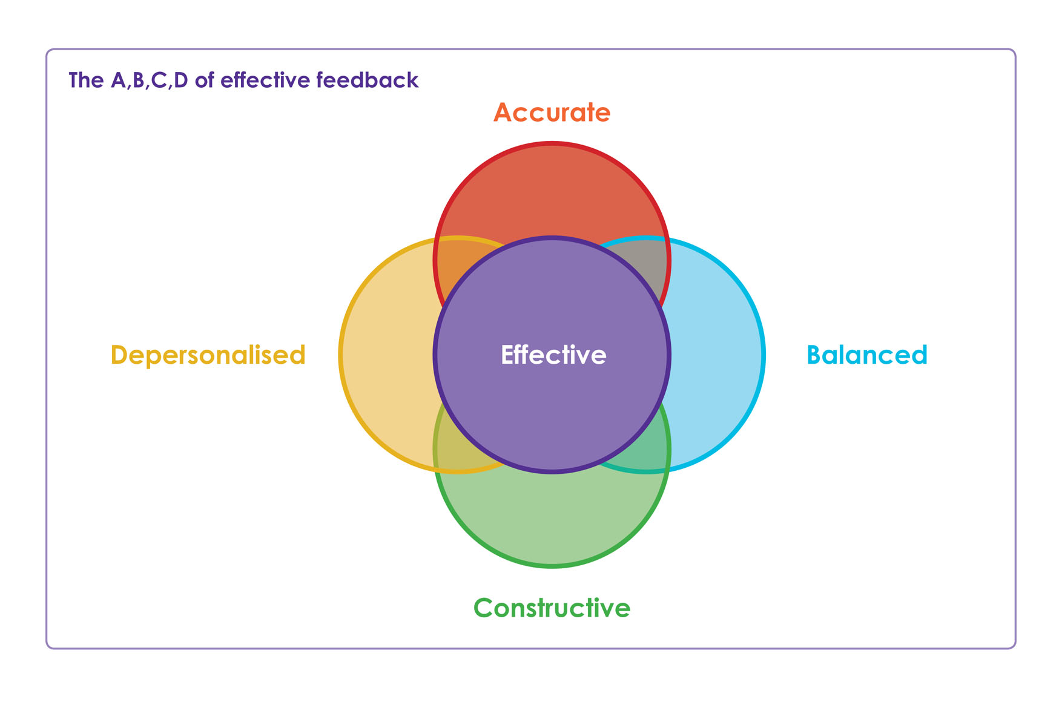
Accurate: When commenting on the learning experience, be specific, and provide evidence for what you are saying. Avoid sweeping generalisations or emotional language. If you have a survey that tells you 67% of people don’t like the feedback they receive, don’t tell staff that 97% don’t like it.

Balanced: Don’t just pass on negative comments to staff, even if that is mostly what you are hearing from students. Say positive things too. This helps soften the blow and makes you look more professional.

Constructive: You are not just here to identify the problems; you are also here to help find a solution too. If you raise an issue, make a suggestion at the same time- this also helps you to look professional.

Depersonalised: Even if students think that a member of staff has done something wrong, it’s always hard to make or receive personal comments. Try not to mention anyone by name in meetings, talk about the class and the impact on the learning experience.

Your notes:

Facilitation

As a review team member you will be responsible for chairing some of the sessions during the review. You will therefore have to facilitate discussions with a range of people to ensure that you get a good picture of their views.

A facilitator’s role is to support and enable the discussion, ensuring everyone who wants to contribute can. They manage the discussion while following the agenda and keeping to time. It can be a challenging role and you will need to juggle a lot of things at once.
Here are some essential points to bear in mind when you facilitate discussions:

Keep to time
The time you will have for the session will not be as long as you would like and you will have a lot to fit in. you will need to involve the other panel members in the questioning and ensure everyone gets the chance to speak. Remember to use closed questioning to draw questioning to a close.

Stay neutral
As a review team member it is important to stay neutral but it is particularly important as a facilitator to ensure that you are perceived to be biased.

Focus
It will help if you keep to the agenda. Use your questioning skills to bring people back to the point if they stray and don’t be afraid of (politely) reminding them of the original question.

Stimulate and encourage responses
It is your responsibility as facilitator to ensure everyone feels comfortable to participate. This is especially important when talking to the student group as some students might not feel comfortable to speak in front of a group, so do your best to ensure the environment is conducive to students feeling comfortable talking. Your listening and questioning skills will be valuable here.

Regulate
Try to avoid letting the same people speak all the time, you need to get as broad an input as possible. As facilitator you are responsible for managing the discussion and should ensure everyone that wants to contribute can.
Your notes:
Tips for effective communication

- Keep good eye contact during conversations.
- Be aware of your body language. Try to keep it open to show that you are interested.
- Avoid negative mannerisms.
- Be attentive. Try nodding, smiling or making small agreeing noises.
- Keep an open mind to what you are hearing.
- Don’t interrupt to impose your solutions on the speaker.
- Clarify your understanding with the speaker.
- Pay attention to the response and let the person completely finish what they have to say.
- Pay attention to non-verbal cues e.g. signs of discomfort or tension.
- Speak slowly and clearly and be consistent.
- Take notes and clarify any points that have not been understood.

Session 4: Practice Review Panel Pre-Meeting

Session Aim

You will get the chance to put the skills learned in the previous session into practice during this session.

Session Objectives

By the end of this session you will:
- Have analysed review paper work;
- Have identified the elements you need to focus on, particularly relating to the student learning experience;
- Have collectively considered what questions you need to ask during the review.

Your notes:

Session 5: Practice meeting with key staff

Session Aim

This session gives you the opportunity to role play as panel members and will allow you to put all you have learned during the day into practice.

Session Objectives

By the end of this session you will have:
- Utilised your questioning, listening and facilitations skills;
- Practised being a review team member.

Your notes:

Resources

Scottish Credit and Qualifications Framework

SCQF
http://www.scqf.org.uk/

SCQF diagram http://www.scqf.org.uk/features/Framework.htm

Scottish Funding Council

Council guidance to higher education institutions on quality from August 2012
http://www.sfc.ac.uk/web/FILES/Circulars_SFC142012/SFC142012.pdf

Subject Benchmark Statements

Subject benchmark statements for honours degrees.
http://www.qaa.ac.uk/AssuringStandardsAndQuality/subject-guidance/Pages/Honours-degree-benchmark-statements.aspx

Subject benchmark statements for master's degrees.
http://www.qaa.ac.uk/AssuringStandardsAndQuality/subject-guidance/Pages/Master%27s-degree-benchmark-statements.aspx

Subject benchmark statements for professional qualifications in Scotland.
http://www.qaa.ac.uk/AssuringStandardsAndQuality/subject-guidance/Pages/Scottishbenchmarkstatements.aspx

Public information

Unistats: The official website for comparing UK higher education course data
http://www.unistats.ac.uk/

Quality Enhancement partners

Higher Education Academy (HEA) provides support to the higher education sector by working with individual universities and organisations within the sector. The work of the Academy is based on guidance from funders on national and UK priority areas.
http://www.heacademy.ac.uk/home

NUS Scotland is a federation of over 60 local students' associations in Scotland representing students studying at colleges and universities. The mission of NUS Scotland is to promote, defend and extend the rights of students, and to develop and champion strong students' unions.
http://www.nus.org.uk/scotland

Quality Assurance Agency Scotland (QAA) aims to develop and operate quality assurance and enhancement arrangements that reflect the needs of higher education in Scotland. Its work covers a broad range of review and development services aimed at supporting the assurance and enhancement of higher education. This includes Enhancement-led Institutional Reviews (ELIR), supporting the Enhancement Themes and coordinating the international benchmarking activities of the Scottish Higher Education Enhancement Committee (SHEEC).
http://www.qaa.ac.uk/scotland/default.asp

Scottish Funding Council (SFC) is the national, strategic body that is responsible for funding teaching and learning provision, research and other activities in Scotland's 42 colleges and 20 universities and universitys. SFC is a Non-Departmental Public Body of the Scottish Government.
http://www.sfc.ac.uk

sparqs exists to assist and support students, students' associations and institutions to improve the effectiveness and engagement in quality assurance and enhancement in institutions across Scotland. sparqs provides support through training, events, consultancy and sharing practice.
http://www.sparqs.ac.uk
Universities Scotland is a membership organisation for Principals at all Scottish universities. It exists to represent and promote Scotland's higher education sector and campaign on its behalf. Universities Scotland work is informed and guided by a series of committees and advisory groups broadly related to the following six policy areas: Learning and Teaching; Research and Commercialisation; Resources & Administration; Widening Access and Equal Opportunities; Internationalisation; and Public Affairs.
http://www.universities-scotland.ac.uk/

t 0131 622 6599
f 0131 622 6597

www.sparqs.ac.uk

This booklet is licensed under a Creative Commons Attribution Non-commercial 3.0 licence. You are free to copy, communicate and adapt the work, as long as you attribute sparqs. A copy of this licence is available at http://creativecommons.org/licenses/by-nc/3.0/

If you require this document supplied in a different format please contact sparqs.

August 2013

